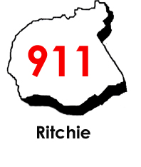

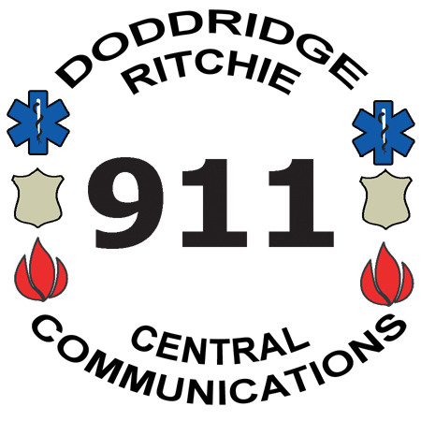
Issue Resolution
Central Communications, Inc.
4317 Lamberton Road, P.O. Box 516
Pennsboro, WV 26415
Phone: 304-659-3770 Fax: 304-659-3772
Mapping & Addressing: 304-659-2979
www.centrale911.com
Executive Director
Eric E. Ashcraft
Board of Directors
Samuel Rogers
Clinton Means
Shawn Glaspell
Steve Ritter

Call Number(s) : | Call Nature :

Date of Incident : | Time of Incident :

Location: | Submission Date:

Submitting Agency: | Submitting Person:

Address: | City: | Zip:

Details of Issue:

Suggested Resolution:

Signature Date
Ver. 12 0725/25

